QMS

1. QMS Desktop Access
The QMS Desktop is a dashboard interface that displays data for hospital departments.
- Hospital & Department Restrictions:
  - Only users belonging to a specific hospital’s department can view its dashboard data.
  - Users who have access to the hospital but are not included in the QC setup cannot see dashboard data.
  - Access is strictly department-specific:
    - A user added to QC for Hospital A, Department X cannot see data for Hospital B or another department in the same hospital.
This ensures data confidentiality and departmental isolation.

2. Workflow Management
This section manages the organizational structure within the hospital for QMS purposes.

Department Management
- Users can add a new department to the selected hospital.
- HOD (Head of Department) Selection:
  - The dropdown includes users who have hospital access, even if they are not QMS users.
  - This ensures that leadership roles can be assigned even if the user isn’t part of QMS yet.

Designation Management
- After creating a department, users can add designations within it.
- When adding a designation:
  - HOD is automatically assigned the highest position in the hierarchy.
  - Reporting structure must be defined:
    - Primary Reporting: Direct supervisor.
    - Secondary Reporting: Backup/alternative supervisor.
This setup creates a clear chain of command for quality control processes.

3. Manpower Assignment
This module manages users within QC for the hospital.
- Users can be:
  - Existing Lab Care users (already in the system).
  - New users added specifically for QC.
- While adding a user, the form collects:
  - Department assignment
  - Designation assignment
  - Primary and Secondary reporting personnel
  - Basic personal information (e.g., name, contact, role details)

User Table Display
- At the end of the form, a table shows two groups of users:
  - Users added to the hospital for QC.
  - Users who have hospital access but are not part of QC QMS.

User Role & Access
- Newly added users are:
  - Exclusively assigned to the selected hospital.
  - Access is restricted to that hospital only.
  - Normal user role is assigned by default.
This ensures hospital-level access control and proper role segregation for QC tasks.

4. Organization Workflow
This section consolidates QC data based on department and year.
- Department Dropdown: Displays all departments of the selected hospital.
- Year Selection Field: Enables selection of the year for which QC data is needed.
- Data Population:
  - Based on selected department and year, all relevant QC module data (like audits, checklists, observations) will be displayed on the dashboard.
This provides a departmental and temporal view of quality management metrics.

Assets

1. Asset Listing
This is the main view where users can see all assets associated with their account.
- Default Display: Only active assets are shown.
- Toggle Option: Users can switch to view all assets, including inactive ones.
- Print QR Button:
  - Opens a popup to configure QR printing.
  - Users can select the asset from a dropdown.
  - They can choose the position of the QR code on an A4 page.
  - The QR code is then printed based on this layout.
- Download Report Button:
  - Generates a PDF report of all assets.
  - Report is filtered to show assets related to the user’s department.

2. Asset Details
A form captures all relevant information about an asset.
- Unique Identifier: Each asset gets a unique number upon creation.
- Department Assignment:
  - Assets can belong to one or multiple departments.
- Procurement Type:
  - Subscription: Ongoing usage-based procurement.
  - One-Time Procurement: Single purchase.
    - Can operate under AMC (Annual Maintenance Contract) or Service Mode.
    - AMC Mode:
      - Service provider assignment is mandatory.
      - Maintenance plans are automatically created according to Frequency and shown in the Maintenance module.
- AMC Details: Must include:
  - Invoice Number
  - Invoice Date
  - Start and End Dates
  - Cost
  - Maintenance Frequency
- Asset Media: Multiple images can be uploaded.
- QR Code Generation: Once saved, the asset gets a QR code displayed on the screen.

3. Other Details
Additional information to provide context and traceability for assets:
- Manufacturer details
- Service provider
- Purchase details
- Supplier details
  - If supplier and manufacturer are the same, a checkbox can be marked.

4. Utility
Utilities are associated tools, consumables, or add-ons used with the asset.
- Displayed in a table under the Utility tab.
- Adding New Utility:
  - Button at the top redirects to the Material Module.
- Manual Updates: Last replaced date of a utility can be updated manually.

5. Consumables
Consumable items associated with an asset (e.g., filters, reagents, small parts):
- Displayed in a tabular format.
- Adding Consumables:
  - Redirects to Material Module.
  - Pre-fills:
    - Consumable option selected.
    - Associated asset pre-selected.
- Usage Calculation:
  - Days of usage are calculated based on the outward date and expiry period.
  - Remaining usage days are updated daily.

6. Documents
Documents related to the asset are managed here:
- Displayed in a table under the Documents tab.
- Document Types: All types are selected by default.
- Adding New Document:
  - Redirects to Document Module.
- Note: Documents are not directly linked to assets; they are linked via validation processes.

7. Service History
Maintenance history and logs:
- Pending Maintenance List: Displays tasks not yet completed.
- Completed Maintenance History: Shows past maintenance activities.

8. Periodic Parameters
Calibration-related data is managed here:
- Users can add parameters and calibration frequency.
- Fields:
  - Parameter: What needs calibration.
  - Periodicity: How often it needs calibration (daily, monthly, quarterly, yearly).
- Automatic Calibration Plan: Based on periodicity, plans are created starting the day after saving data.

9. Checklist
Checklists track recurring tasks or verifications for assets:
- Users can add multiple checklist questions.
- For each question:
  - Periodicity: How often it should be executed.
  - Assignee: Person responsible for completing the checklist.
- Checklist Plan Automation: Plans are automatically generated.
- Unassigned Checklists: Displayed to all users in the department.

Maintenance & Service

Maintenance Management

1. Listing Page
- The system displays all assets requiring maintenance that are associated with the logged-in user’s department.
- Maintenance records are displayed in a tabular format, allowing users to quickly view key details.
- A “Generate Report for All Maintenance” button is provided at the top of the table to create a consolidated report of all listed maintenance records.
- Each maintenance record also includes an option to generate an individual report.
- An edit icon is available for each record. Clicking it redirects the user to the Service Schedule Page, where details of the selected record are pre-populated for efficient updates.

2. Visit Management
- Users can schedule a Maintenance Visit from the Visit Tab using a dedicated form.
- The form includes a dropdown for Visit Type, with the following options:
  - Fault
  - Servicing
  - AMC (Annual Maintenance Contract)
  - Calibration
- Another dropdown allows users to select the Call Type, which can be:
  - Emergency
  - Priority
  - Normal
- Visits are always created against a specific asset.
- To create a visit, the user must associate a Service Provider with the selected asset.
- When an asset is selected, the system automatically fetches and displays the pre-linked Service Provider for that asset.
- Once the visit is saved:
  - An email notification is sent to the assigned Service Provider.
  - A corresponding task is created in the Task Manager.

3. Service Schedule
- The Service Schedule Page initially displays a list of all pending maintenance tasks for the selected hospital.
- A form is provided below the list to update the service status of a selected maintenance task.
- Users can update the service status with the following options:
  - In Progress
  - Closed
  - Escalate Visit
  - Terminate Call
- If Escalate Visit is chosen, the system prompts the user to specify the next visit date.
- The form also includes:
  - A dropdown to select the Spare/Utility associated with the asset.
  - A dedicated field to enter the cost of the spare/utility.
- Each update is logged in a History Section for the selected asset.
- The history provides a chronological timeline of all service activities and is displayed directly below the update form.

4. History
- The History Page begins with a list of assets associated with the hospital.
- Users can browse and select an asset to view its maintenance records.
- Once an asset is selected:
  - A Pie Chart is displayed, showing the number of maintenance activities per month.
  - Users can toggle to view another chart representing the monthly cost incurred for maintaining the asset.
- Additionally, the last maintenance history of the selected asset is displayed in a dedicated card.
  - This card provides key details of the most recent maintenance activity, enabling quick reference.

Material
Listing
- The Material Listing displays a list of materials in the selected hospital.
- A summary of material stock is shown at the top of the table, providing the following details:
- Total Material
- Stockout Items
- Low Inventory Items
- Unused Inventory
- Expiring Soon
- Pending Orders
- For materials with 0 available quantity, the delete icon is enabled; for all others, it is disabled.
- A PDF report can be generated for each material or for all materials in the hospital using the button provided at the top of the table.
Inventory
- One Inventory can be added against multiple assets and departments.
- The inventory is categorized into three types:
- Material (not linked to any asset)
- Utility (requires asset selection)
- Consumable (requires asset selection and the user must provide the Expiry/Usage Period in days)
- A default material list is provided, and the user can select from the default list.
Multiple images can be uploaded for a single material.
Role-based
Role-based access control must be applied. A user should only be able to view the list of Materials belonging to the departments assigned to them. Within their assigned departments, users can perform the following actions based on access rights: View Details, Edit, Download Report, and Delete."

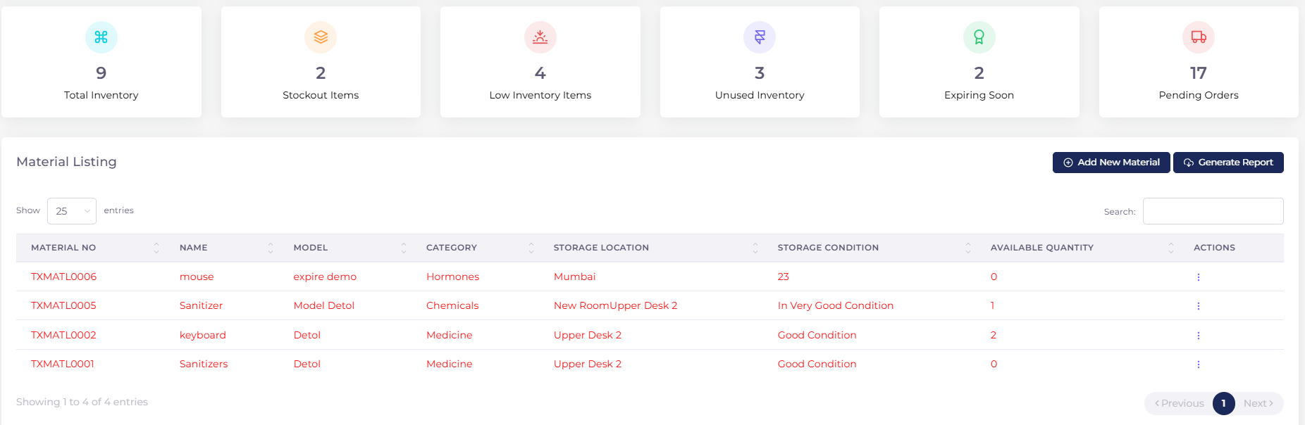
Add New Material
- "In Material Management, when adding a new Material, the following fields must be mandatory: Material Name, Model Name, Material Category (–Select–), Material Used By Department, Annual Consumption, Average Lead Time (Days), Minimum Quantity, Certification and Accreditation, Utility/Material/Consumable (–Select–), Location, Condition, Material Description, and 'Drop image here or click to upload.' In the 'Material Used By Department' field, all departments created in QMS Department Management should be listed, and tasks can be assigned to the respective users."
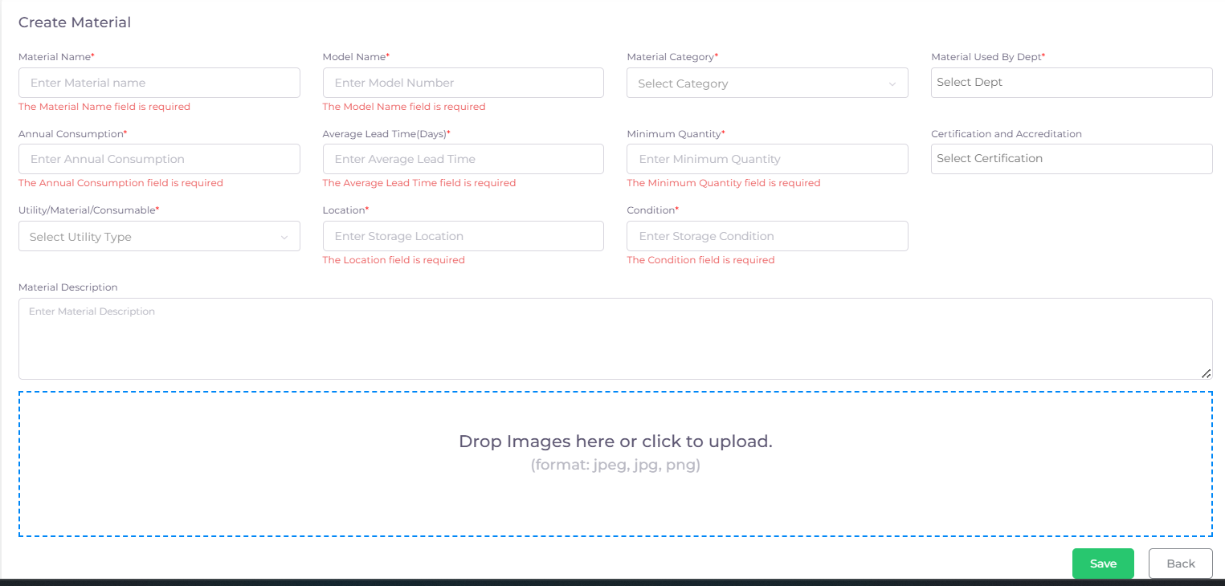

Vendor
- The Vendors Page includes a form to add a vendor for registered materials.
- A vendor can be registered for multiple materials.
- For selected material user has to add the unit cost and Lead time(days).
Below the form, a list of registered vendors is displayed along with their contact details.
In Vendor Management, a Vendor can be added. Once added, the Vendor will appear in the Vendor List and will have access to view the requests assigned to them."
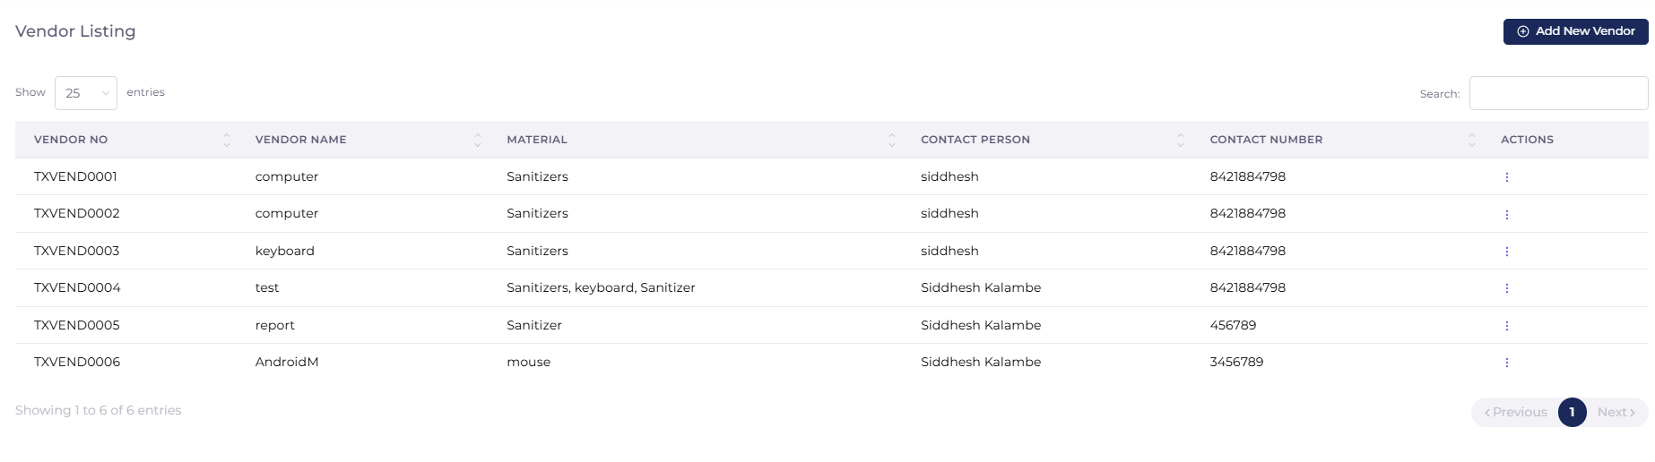
Add New Vender Page
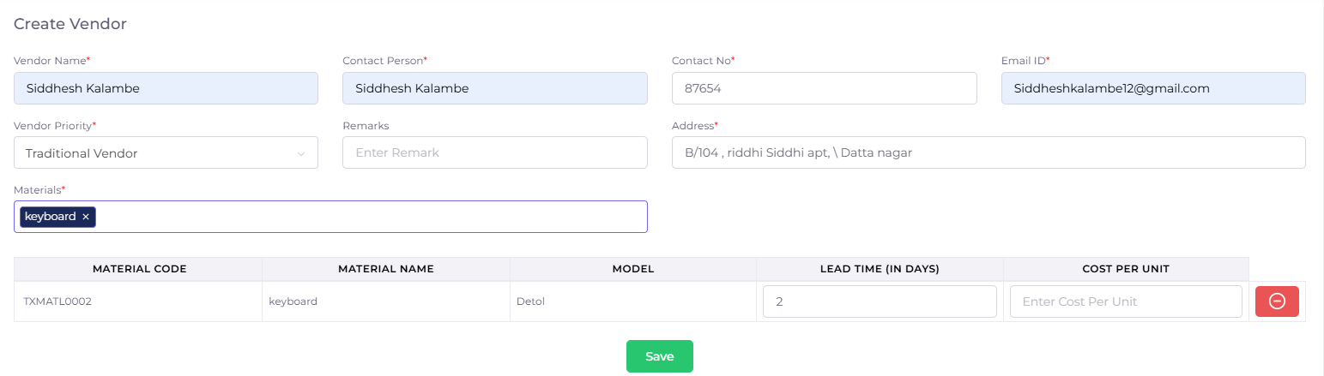

Requisition
- The Requisition Page is used to place orders for materials.
- At the top of the page, a tabular format displays all the vendors for the selected material.
- Users can select a vendor, and based on the selection, the relevant data is populated in the form below. The user only needs to enter the quantity of the material.
When the requisition is raised, all the users from selected departments receive an email notification.
Role Access
"A user can raise a request to the Vendor for a device or product, specifying the required quantity and quality. The Vendor will have access to view the requests raised by the user.

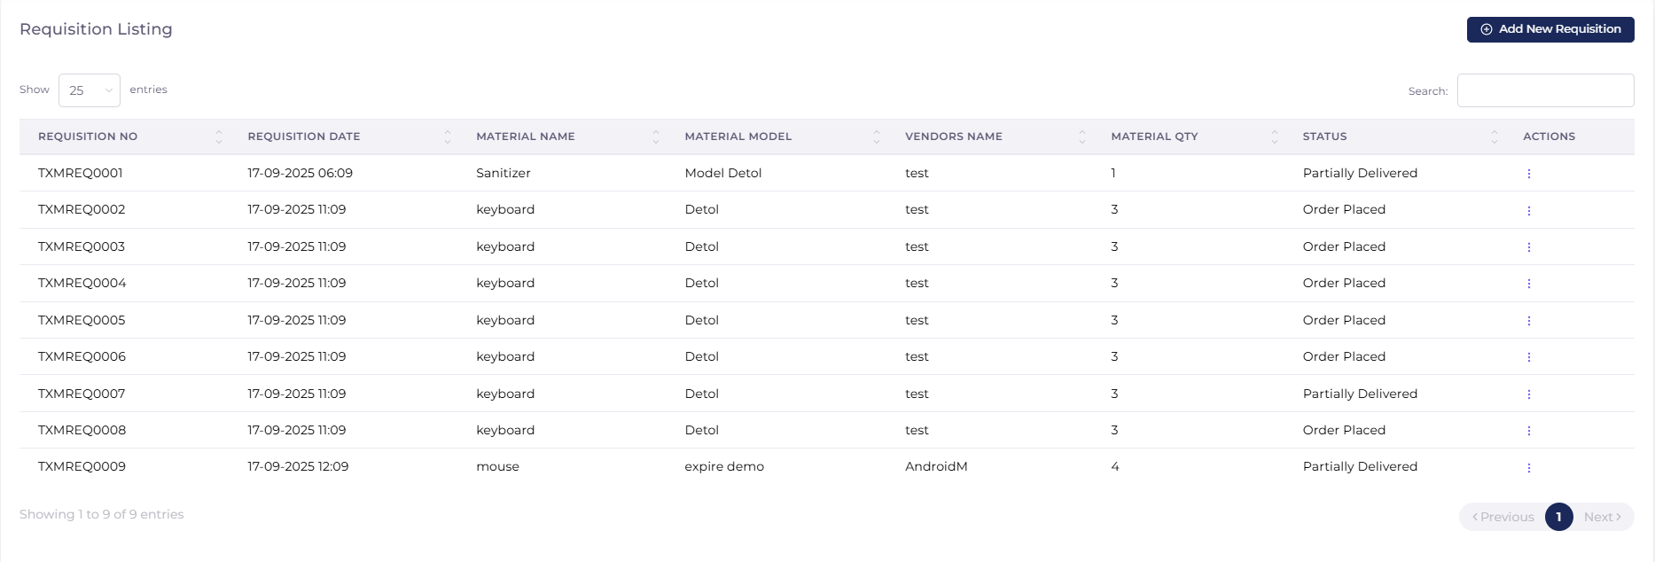
In Listing Actions the it have a Permission to Edit and Inward To Create an Inward
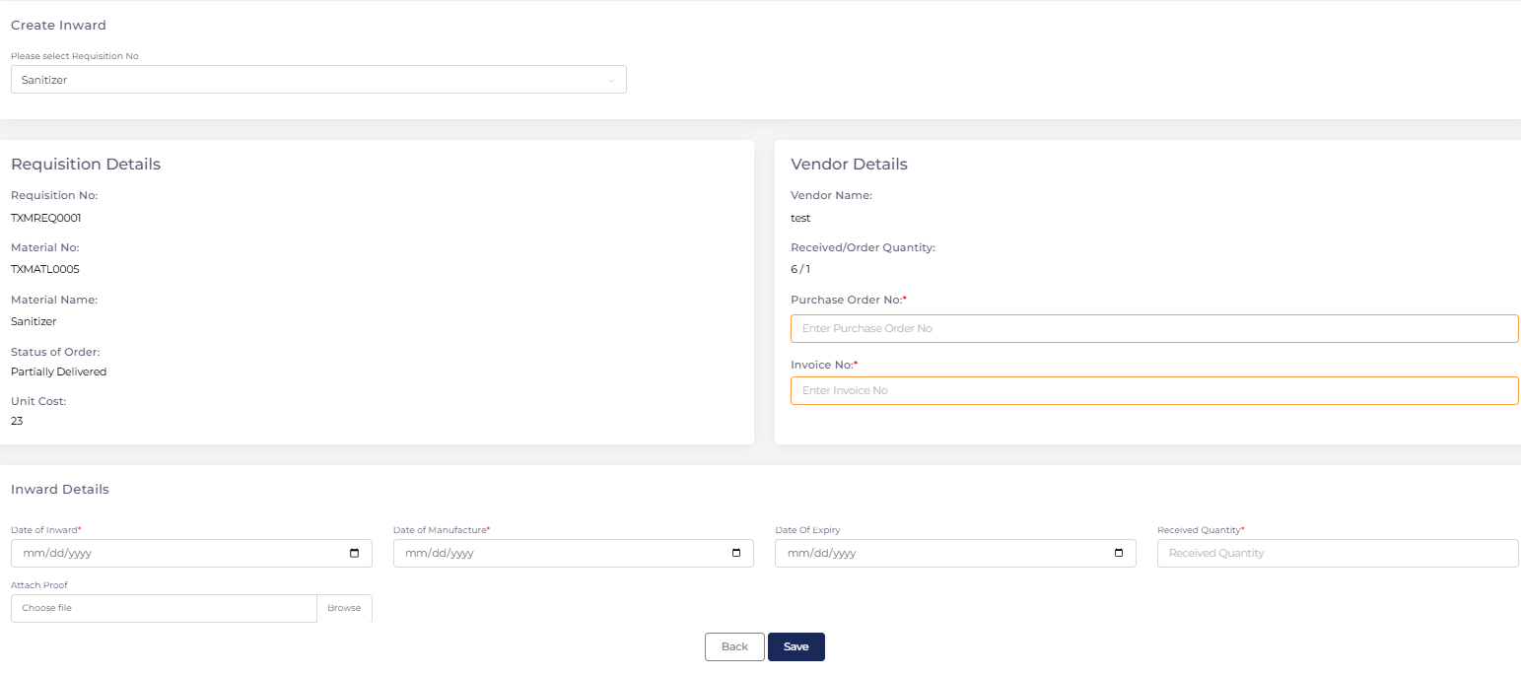

Add New Requisition we have to search the name of material that has been created in Material
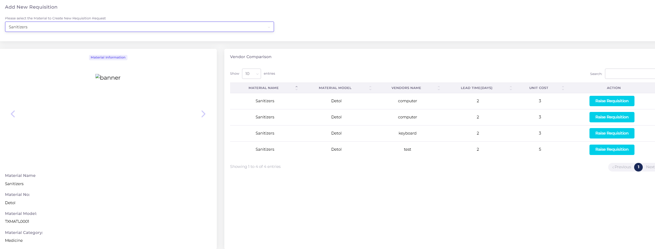

Inward
- In the Inward Tab, whenever material is received, the inward is raised.
- Users can search the requisition using the requisition number or material name.
- The basic details of the selected material requisition will be displayed, and the user must enter the invoice details and the quantity received.
- A history of the inward transactions for the selected material is displayed in a tabular format below the form.
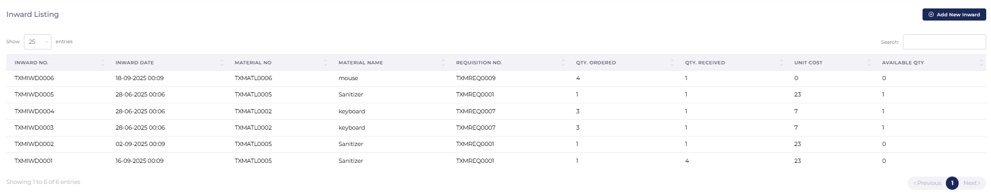
Add New Inward
Users can search the requisition using the requisition number or material name
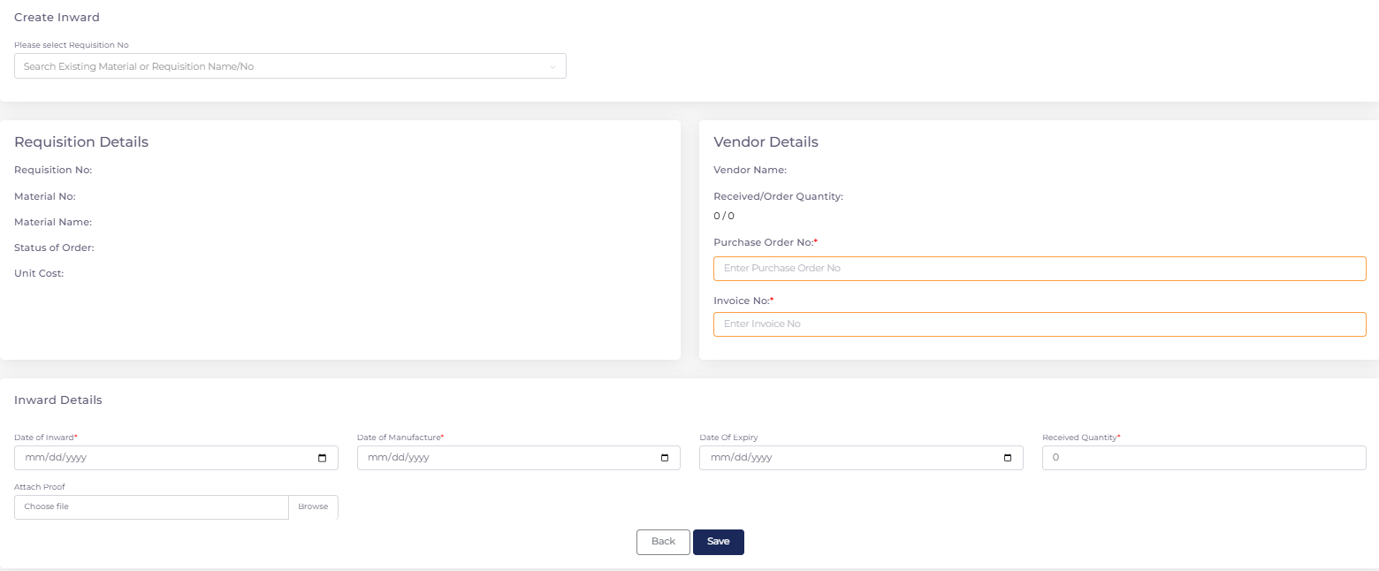
Outward
- The Outward Tab is used when any department takes material from the inventory.
- Only departments assigned to the material are displayed in the department dropdown.
- Users must select a user from the department who will receive the material and specify the quantity.
A list of recently consumed materials is displayed below the outward form.
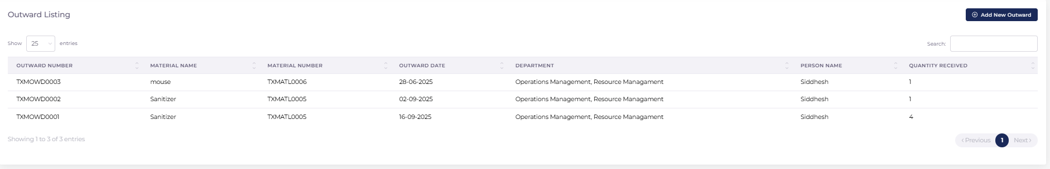
Add New Outward
- Users must select a user from the department who will receive the material and specify the quantity.
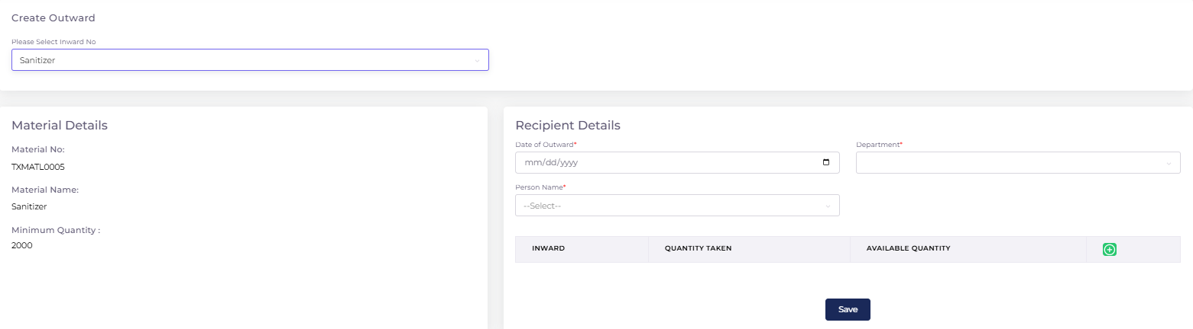
Expiry
The Expiry Tab lists all the expired materials in a tabular format.
The Expire data will display then the inward data is expire it comes to outward then the expire data is listed in expired list
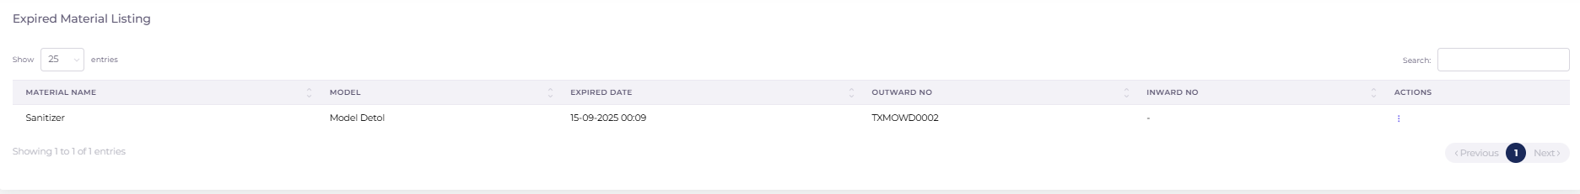
Procurement
- In the Procurement Tab, the user must search and select a material.
- For the selected material, the following details are displayed:
  - Annual Consumption Details
  - Material Consumed History Annually
  - Price Fluctuation on Each Purchase Annually
- Annual Consumption Details include:
  - Annual Consumption Projected
  - Annual Consumption Done
- Material Consumed History Annually shows the material consumption count for each month in a pie chart.
- Price Fluctuation is represented in a line chart to visualize the changes over time. 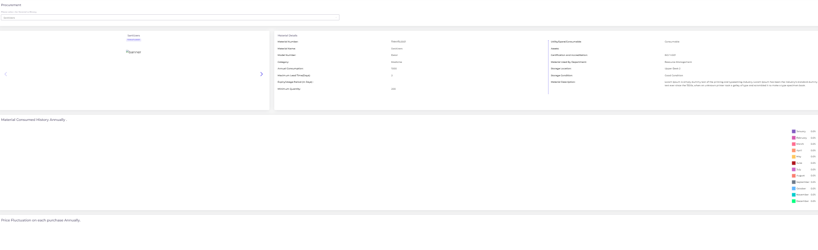
Calibration

1. Calibration Plan Generation
- Calibration plans are generated automatically based on the periodic parameters configured for each asset.
- The scheduler service ensures that plans are created in advance to maintain timely calibration schedules.
- Plans are displayed department-wise according to the logged-in user, ensuring users only see calibration tasks relevant to their department.

2. Plan Assignment & Execution
- For each calibration plan:
  - A Standard Device (Calibrator) must be mapped.
  - The plan must be assigned to a specific assignee.
- If a plan remains unassigned, it can be executed by any user from the respective asset’s department.
- Once a Standard Device and Assignee are mapped for an asset, the system will auto-fill these details for future calibration plans of the same asset.

3. Calibration Process
- After mapping a Standard Device, users can enter the calibration readings.
- If the Standard Device’s due date has expired, the system will restrict readings until the device is updated with a valid due date.

4. Task Management Integration
- For every calibration plan generated, a corresponding Task will be created in the Task Manager module.
- The task includes details of the plan, asset, and assigned user.

5. Standard Device (Calibrator) Management
- Users can register a new Standard Device (Calibrator) by:
  - Entering its parameters (make, model, serial number, etc.)
  - Uploading its certificate
  - Providing any additional required details
- All Standard Devices added for the hospital are displayed in a list below the Standard Device form.
- Users can view the uploaded certificate for each calibrator and edit device details when needed.

6. Documentation & History
- In the Documentation Tab, users can:
  - View the complete calibration history of a selected asset.
  - Filter history by a date range.
  - View all documents uploaded during calibration along with historical data.

7. Planning & Scheduling
- In the Planning Tab:
  - A table will display all pending calibration plans up to the current date, grouped by date.
  - A second table will display upcoming calibration plans, categorized as Monthly, Quarterly, and Yearly plans.

8. Status Tracking
- In the Status Tab, calibration plans will be displayed as cards under different categories:
  - Today’s Plans
  - Overdue Plans
  - Upcoming Plans
- Each card will include:
  - Plan details (Asset, Department, Assignee, Standard Device, etc.)
  - A progress chart showing the percentage of completion for that plan.
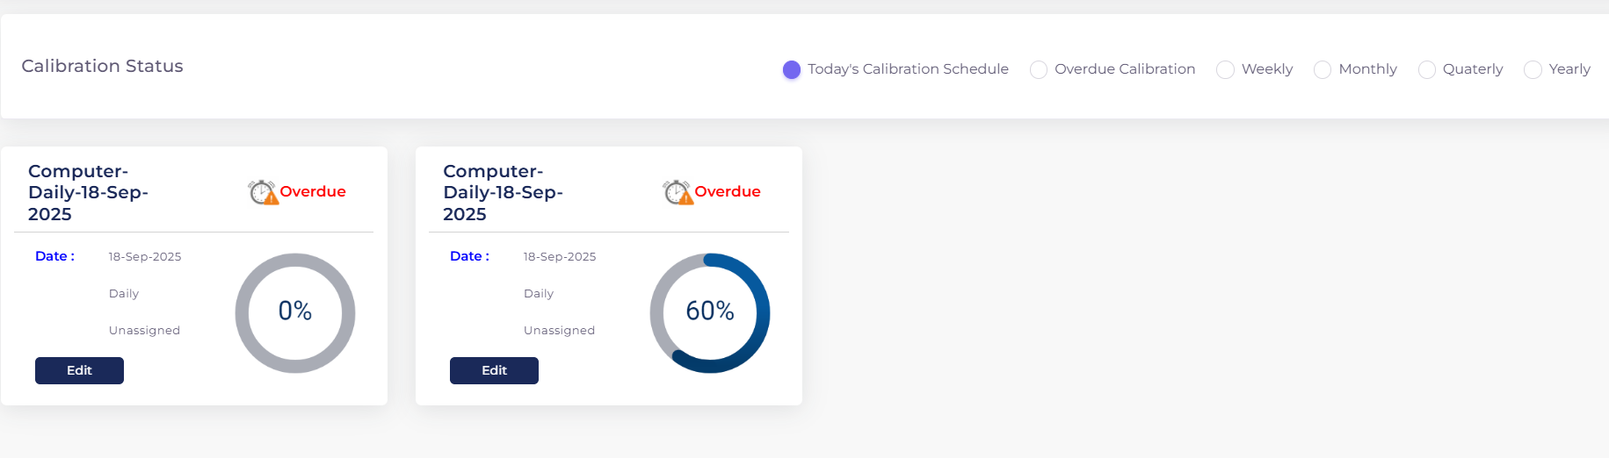
Execution
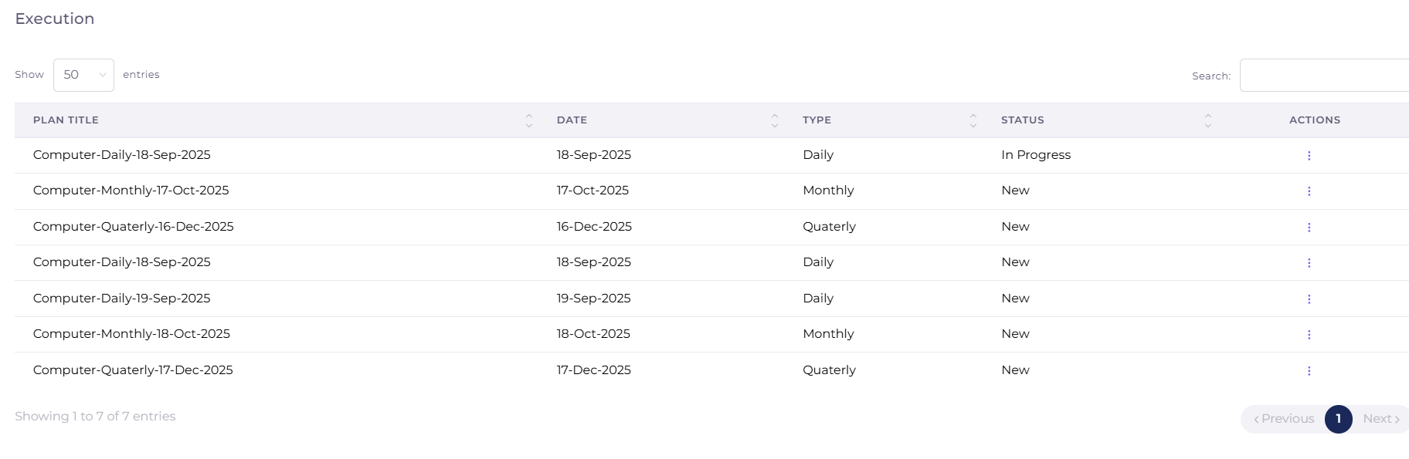
User have an access to view and Download

KPI

KPI Management
- User Access & Entry
  - KPI can only be filled by users who are enabled for KPI access while being added in the QC Manpower Module.
  - Users are required to fill in their KPI data on a daily basis.
  - Once a KPI entry is submitted, it cannot be edited.
- Question Selection
  - Users can choose the number of KPI questions they wish to answer.
  - Once questions are selected, the same set of questions will be displayed by default for all future entries.
  - Users can view all available KPI questions by clicking the “Show All” button above the KPI table.
- My KPI Section
  - In the My KPI section, users can:
    - View their own KPI data.
    - View the KPI data of their lower hierarchy (subordinate users).
  - Only one user’s data can be viewed at a time.
  - The selected user’s data will be displayed in:
    - Line Graph format for trend visualization.
    - Tabular format for detailed records.
  - Data can be filtered by date or period selection for each KPI section.
- Lab KPI Section
  - In the Lab KPI section, multiple users can be selected at once.
  - Users can view:
    - Their own KPI data.
    - KPI data of their lower hierarchy.
  - Lab KPI provides a comparison of multiple users in both:
    - Table format
    - Chart format
  - At the end of the Lab KPI section, the Benchmark of the selected Hospital will be displayed.
- Benchmark Setting
  - Hospital Users have access to the Benchmark Tab.
  - Benchmarks can be set for each KPI section within the Benchmark Tab.
  - These benchmarks are used as reference points and are displayed in the Lab KPI comparison.

Training

Training Management

1. Training Listing
- On the Training Listing Page, all training courses assigned to the logged-in user’s department are displayed in a tabular format.
- This allows users to quickly identify the courses relevant to their department.

2. Course Creation
- Any user within the hospital can create a new course.
- A single course can be assigned to multiple departments at once.
- Each course can include multiple chapters, and each chapter may contain:
  - Videos
  - Images
  - Text content

3. Course Assignment
- All users belonging to a department that is assigned a course are required to complete the course.
- The Assign Tab is used to allocate courses to users.
- During assignment:
  - The course is selected.
  - Based on the selected course’s department, the relevant users are auto-populated.
  - Start Date and End Date for the course are set.
  - The assignment data is then saved in the system.

4. Notifications & Task Management
- Once a course is assigned:
  - The assigned users receive an email notification informing them about the training.
  - A task is automatically created in the Task Manager, ensuring that the training assignment is visible and trackable.
Documentation

Document Management

1. Document Upload
- Users can upload documents such as:
  - SOPs (Standard Operating Procedures)
  - Process SOPs
  - Product SOPs
- While uploading, users must provide additional details including:
  - Effective Date
  - Expiry Date
  - Applicable Departments (one or multiple)

2. Approval Workflow
- Once a document is added, it must be reviewed and approved by the Head of Department (HOD) of each selected department.
- If a document is marked as Emergency, it will appear in the Emergency Module once it is approved and released.
- After all assigned HODs approve the document, it will be moved to the Release Tab.

3. Release Process
- A document must be released by all HODs of the respective departments.
- Only after all HODs complete the release does the document become accessible to all users within the assigned departments.
- Upon release:
  - An email notification will be sent to all department users.
  - A task will be created in the Task Manager for each user to provide feedback on the released document.

4. SOP Reference Library
- The module includes an SOP Reference Library under the SOP Tab.
- All uploaded, approved, and released SOPs are stored here for quick access and reference by users.

Emergency Plan
• Emergency Listing Page:
- Displays all closed emergency plan documents.
- Search: Users can search for documents based on relevant fields.
- Pagination: Allows navigation through multiple pages of documents.
• Columns Displayed in Listing:
- Title: Name of the emergency plan document.
- Document Number (Doc No): Unique identifier for the document.
- Owner: Person responsible for the document.
- Category: Type or classification of the emergency plan.
- Department: Department associated with the document.
- Effective Date: Date when the document becomes effective.
- Action:
  - View Button: Opens and displays the uploaded document file for review.
• Functionality:
- Users can search documents quickly.
- View uploaded files directly from the listing without navigating elsewhere.
- Efficient document tracking with clear department, category, and owner information.

Change management
Users can raise a Change Request (CR) for a closed document added through the Document Module.
- While adding a request
  - -User can change document title, document category,priorty & type
  - For the selected document,
  - -users can take a screenshot to indicate where the change is required.
  - -Click on save

- After saving document
  - The document is listed in cr index page with new cr number and cr title
  - And the document status is Under Revision

- Action→resolution
  - The document owner only have access to resolve the document
  - In action click on Resolution
  - New page open in new page The document detail is listed ther and documrt screen shot also attached
  - Also you can view the document in onclking on eye btn
  - Attach the document and add feed back like justifican , impact, resolution
  - Click on save
  - The document status get update to Under Approval

- Action→Dowlode
  - The document get download

- Action→Delete
  - After clicking on delete
  - The document status get update to Absolute
CAPA

CAPA Management

1. CAPA Creation
- Users can raise a CAPA against any of the following:
  - Department Process
  - Product
  - Patient
  - Person
- Once a CAPA is raised, a CAPA Plan is automatically created, consisting of the following stages:
  - Investigation
  - Implementation
  - Completion

2. Assignment & Notifications
- For each stage of the CAPA plan:
  - A responsible user is assigned.
  - A due date is defined.
- After the plan is saved:
  - An email notification is sent to all assigned users.
  - A task is created in the Task Manager for each assigned user’s action.

3. Investigation Stage
- In the Investigation Tab, the assigned user must provide the following details:
  - Initial Risk
  - Action Recommended
  - Occurrence Date
  - Detection Rating
  - Supporting Attachments (as proof)

4. Implementation Stage
- In the Implementation Tab, the assigned user must provide the following:
  - Action Taken Date
  - Completed By (Responsible Person)
  - Plan Type (Corrective / Preventive)
  - Final Action Taken
- The user must also mark whether the implementation is completed.
- Once implementation is marked as completed, the CAPA Plan is released.

5. Intimation & Feedback
- If the CAPA is set to “Intimate All”:
  - An email notification is sent to all users for feedback.
  - A feedback task is created for each user.

6. Task Closure
- After each stage action (Investigation, Implementation, Completion) is completed, the corresponding task is automatically closed in the Task Manager.

7. Effectiveness Check
- The Effectiveness Check Section displays feedback results in a Pie Chart format, allowing management to analyze CAPA effectiveness at a glance.

Audit

Audit Management

1. Audit Initiation
- An Audit can be initiated by any user assigned in the QC Department.
- The Auditor must be a user from the hospital.
- A single audit can be created against multiple departments at once.

2. Auditee Selection
- After departments are selected, the list of eligible users is displayed in a table with checkboxes.
- The audit creator can select specific users to participate.
- Only the selected users will be designated as Auditees for the audit.

3. Audit Question Setup
- The user creating the audit can:
  - Add any number of audit questions.
  - Attach supporting documents or files against each question.
- These questions will later be answered by the selected auditees.

4. Checklist Completion
- Selected auditees must answer the audit questions in the Complete Checklist Tab.
- For each question, a chat option is available to enable communication between the Auditee and Auditor in case of clarifications or doubts.
- The Auditor will also review the responses from the same tab.

5. Answer Review & Approval
- Once the Auditor is satisfied with an answer, they will:
  - Provide a Remark.
  - Mark the Status of the question (e.g., Confirmative / Non-Confirmative).
- After the status is marked, the chat option for that question is disabled, preventing further discussion.

6. Audit Summary
- In the Audit Summary, users can:
  - Search audits by title.
  - Select an Auditee’s name to view detailed audit records.
- Upon selection, the Audit Details are displayed.
- All auditees are shown in a table with an Action Column, where they can be marked as Interviewed.

7. Non-Confirmative Tracking
- All audit questions marked with Non-Confirmative status will be displayed in the Confirmative Tab for tracking and corrective action.

8. Audit Gap Analysis
- The Audit Gap Section shows all pending work within the selected:
  - Module
  - User
  - Date range of QC
- A redirect button is provided within the table to take the user directly to the respective module where the pending work exists.

CheckList

Checklist Management

1. Checklist Plan Creation
- Checklist plans are generated automatically based on the periodicity defined in the Checklist Tab of the Asset Module.
- Each asset will have its own checklist plan created according to the configured schedule (e.g., daily, weekly, monthly).

2. Question Assignment
- For each checklist plan, individual questions can be assigned to different users.
- If a user is not explicitly assigned to a question:
  - Any user from the same department as the assigned asset will be allowed to answer that question.

3. Checklist Execution
- Assigned users (or eligible department users) must answer the checklist questions according to the plan.
- Users can upload attachments or provide comments, if required, as part of their response.

4. History & Tracking
- A History Section is available to view all previously completed checklist data.
- History records include:
  - Asset details
  - Checklist questions and responses
  - User who submitted the response
  - Submission date and time
- This allows users and auditors to track compliance and review past performance for accountability

